**PORTFOLIO WEBSITE**

**INDUSTRIAL TRAINING PROJECT REPORT**

***Submitted in partial fulfilment of th*e *requirements for the award of the degree***

***of***

**BACHELOR OF TECHNOLOGY**

***in***

**COMPUTER SCIENCE ENGINEERING**

***by***

**Ayush Luthra**

**Enrolment No: 35915602719**



**DEPARTMENT OF INFORMATION TECHNOLGY**

**DR. AKHILESH DASS GUPTA INSTITUTE OF TECHNOLOGY & MANAGEMENT**

**(AFFILIATED TO GURU GOBIND SINGH INDRAPRASTHA UNIVERSITY, DELHI)**

**NEW DELHI – 110053**

**CERTIFICATE OF TRAINING**



CERTIFICATE VALIDATION: <https://www.cert.shapeai.tech/verify/2f1Vpt>

# ABSTRACT

This project demonstrates the use of Frontend Web Development Technologies using HTML, CSS and, BS4. This project is a template of a personal portfolio of an individual that reflects himself to the industry.

This portfolio in itself is a project that reflects the designing skills of the individual who made it and can be used as a template for selling too.

Link to view the Website: <https://portfolio-theta-ochre.vercel.app/>

# ACKNOWLEDGEMENT

I would like to express my special thanks of gratitude to my Sumer Training Instructor Mr. Aditya Gussain as well as my college faculty members who gave me an opportunity to work on this project. It helped me a lot to learn about research and I came to know about a lot of new things. I am really thankful to all of them.

Secondly, I would also thank my parents and friends who helped me in finalizing this project within the limited time frame.

And a special thanks to our HOD Sir Mr. Anupam for providing me this opportunity.

Once again, thank you everyone who are involved in making this project a success.

# TABLE OF CONTENT

Contents

ABSTRACT 3

ACKNOWLEDGEMENT 4

TABLE OF CONTENT 5

LIST OF FIGURES 6

LIST OF TABLES 7

LIST OF ABBREVIATION 8

LIST OF SYMBOLS 9

CHAPTER 1: INTRODUCTION 10

1.1 INTRODUCTION 10

1.1.1 PORTFOLIO 10

1.2 OVERVIEW OF TECHNOLOGIES USED 10

1.2.1 HTML 10

1.2.2 CSS 10

1.2.3 BOOTSTRAP 10

1.3 BUILD VERSION OF TECHNOLOGIES USED 10

CHAPTER 2: BREIFING THE FEATURES 11

2.1 COMPONENTS USED 11

2.2 FEATURAL COMPONENTS 11

2.2.1 NAVBAR 11

2.2.2 TITLE SECTION 11

2.2.3 RECOMMENDATION SECTION 12

2.2.4 TECHNOLOGY STACK SECTION 12

2.2.5 PROJECTSS SECTION 13

2.2.6 ABOUT ME SECTION 13

2.2.7 BLOGS SECTION 14

2.2.8 FOOTER 14

REFERECES 15

# LIST OF FIGURES

Figure 1 navbar 11

Figure 2 Title Section 11

Figure 3 Recommendation 12

Figure 4 Technology Stack 12

Figure 5 Projects 13

Figure 6 About 13

Figure 7 Blogs 14

Figure 8 Footer 14

# LIST OF TABLES

Abbreviations Table……………………………………………………………………………………………..8

Symbols Table…………………………………………………………………………………………………...9

Version Table…………………………………………………………………………………………………..10

# LIST OF ABBREVIATION

|  |  |
| --- | --- |
| **HTML** | Hyper Text Markup Language |
| **CSS** | Cascading Style Sheet |
| **BS4** | Bootstrap 4 |
| **WebD** | Web Development |
| **JS** | Java Script |
| **Navbar** | Navigation Bar |

# LIST OF SYMBOLS

|  |  |
| --- | --- |
| **&** | AND |

# CHAPTER 1: INTRODUCTION

## INTRODUCTION

The project Portfolio Website is a WenD project of a portfolio profile. The project is a static & responsive website of a portfolio developed using HTML, CSS & BS4. This is a single page portfolio template that consists of various components that describes an individual who uses this template of portfolio website.

### PORTFOLIO

A Portfolio is a professional document used to describe an individual in the profession he follows. A portfolio can be in the form of a document or a website. A portfolio defines an individual as an asset to his following profession and is similar to a resume.

## OVERVIEW OF TECHNOLOGIES USED

The technologies used in this project are: -

### 1.2.1 HTML

HTML stands for Hyper Text Markup Language. It is a markup language that is used to design the skeletal structure of a web page.

### 1.2.2 CSS

CSS stands for Cascading Style Sheet. It was developed to make web page designing easier with respect to the primitive ways of designing where HTML attributes were used to design the web page. In short, it is a language that is used for designing a web page. It is like a skin of a web page.

### 1.2.3 BOOTSTRAP

Bootstrap is a framework of CSS. It uses CSS selectors (especially class selector) to set up the designing component in HTML. It consists of premade custom styles designed in CSS & JS. It is used to make beautiful and standardised responsive designs that follows mobile first approach.

## BUILD VERSION OF TECHNOLOGIES USED

|  |  |
| --- | --- |
| **TECHNOLOGY** | **VERSION** |
| **HTML** | HTML5 |
| **CSS** | CSS3 |
| **BOOTSTRAP** | BS4 |

# CHAPTER 2: BREIFING THE FEATURES

## 2.1 COMPONENTS USED

The list of components this portfolio website consists of is: -

* Navbar
* Title Section
* Recommendation Section
* Technology Stack Section
* Projects Section
* About Me Section
* Blogs Section
* Footer

## 2.2 FEATURAL COMPONENTS

The features provided by the components is as discussed below: -

### 2.2.1 NAVBAR

The Navbar used consists of a branding, contact me button and a blogs link. Where, branding link serves as a home button link which redirects to top of the page. Contact me button directly redirect to the mail of the portfolio user. And the blogs link redirects to the blogs section.



Figure 1 navbar

### 2.2.2 TITLE SECTION

The Title Section consists of the portfolio’s user image, user name and, the designation of the user.



Figure 2 Title Section

### 2.2.3 RECOMMENDATION SECTION

The Recommendation section recommends the portfolio’s user recommendation made by others towards him. It is scrollable section that can scroll in the x – direction (horizontally).

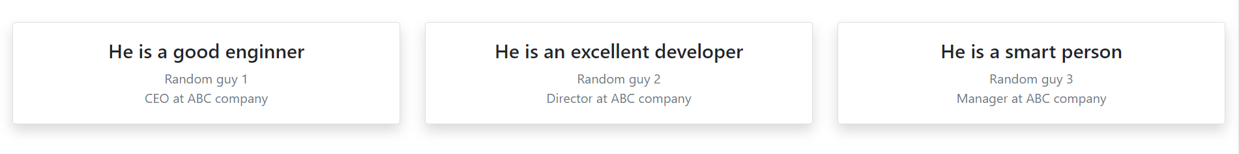

Figure 3 Recommendation

### 2.2.4 TECHNOLOGY STACK SECTION

The Technology Stack Section reflects the skill set of the portfolio’s user and the level he/she have of that particular skill. Where, 1, 2 & 3 stars means beginners level, intermediate level and advanced level of knowledge respectively.

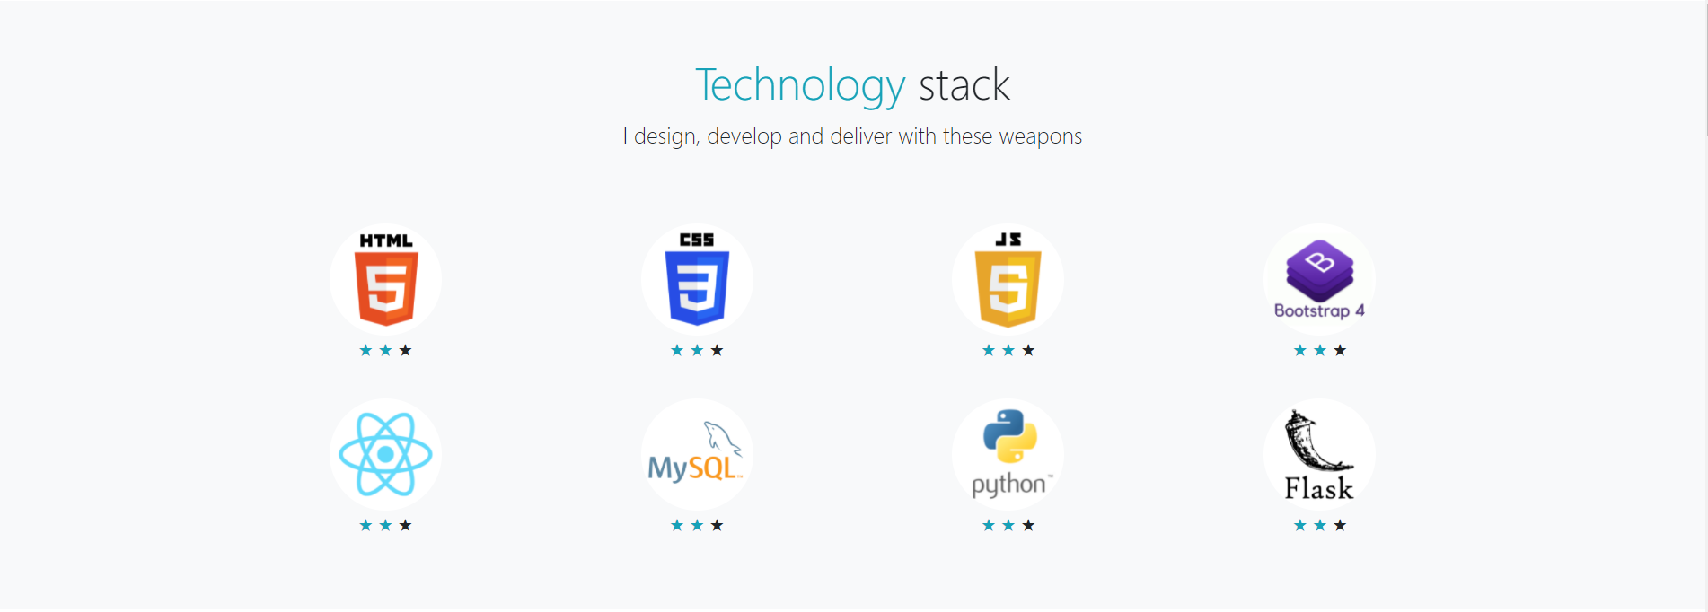

Figure 4 Technology Stack

### 2.2.5 PROJECTSS SECTION

The Project Section consists of the projects that the portfolio’s user had made and a short description about it.

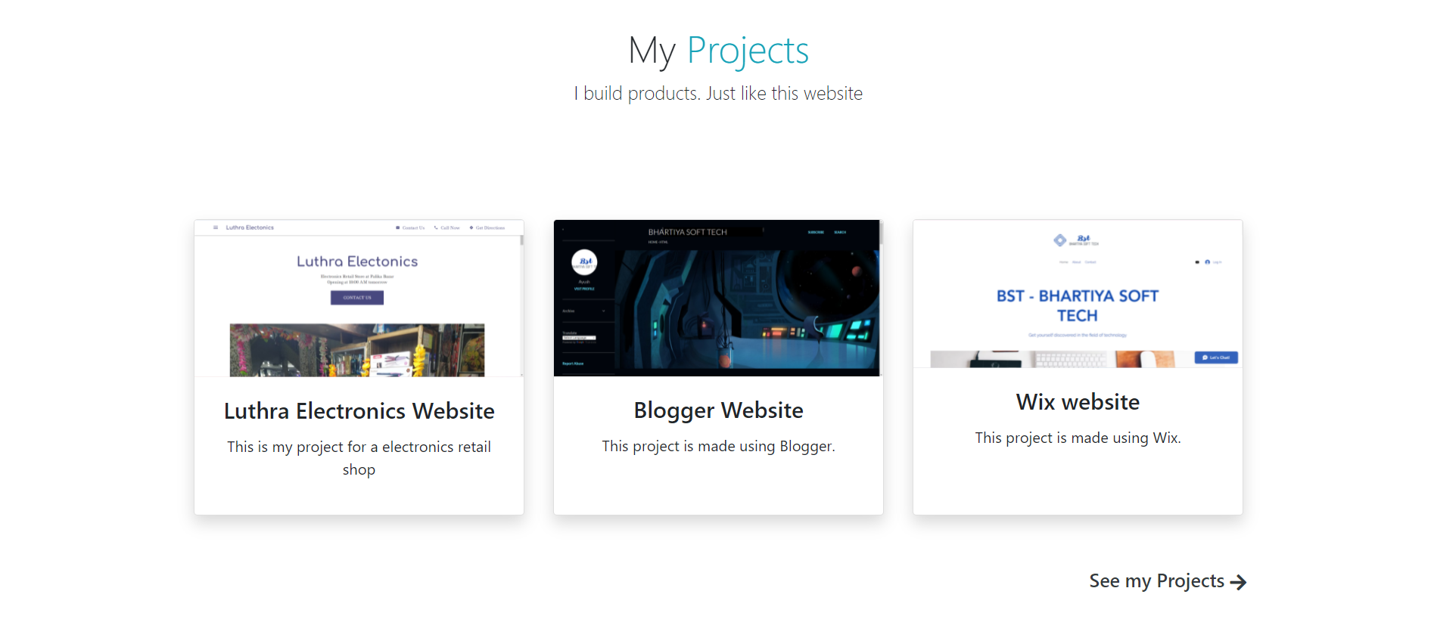

Figure 5 Projects

### 2.2.6 ABOUT ME SECTION

The About Me section compromises of the description of the portfolio’s user.

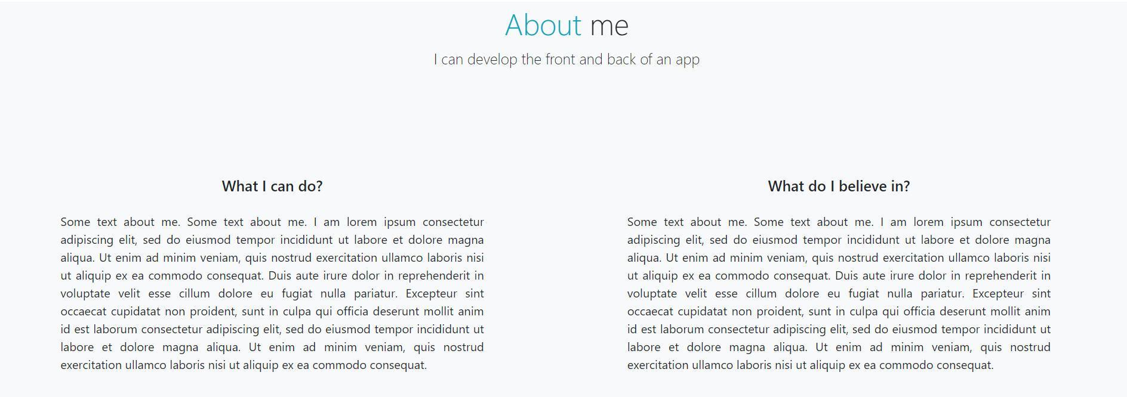

Figure 6 About

### 2.2.7 BLOGS SECTION

The Blog Section compromises of the blog posts that the portfolio’s user composes and its description. And clicking the card will redirect to the full blog.

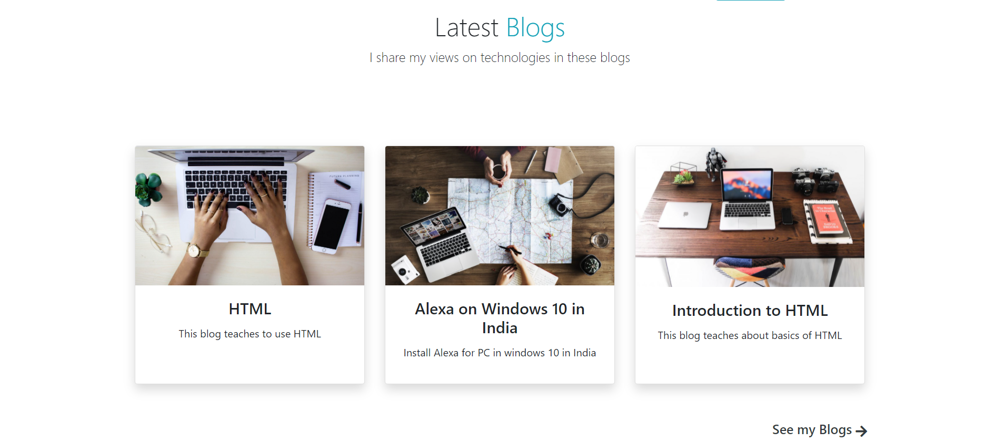

Figure 7 Blogs

### 2.2.8 FOOTER

The Footer compromises of the copyright section, social media links, other links and about the website/user.  
It also compromises of a let’s talk button which redirect to calling app of the device to call the portfolio’s user.

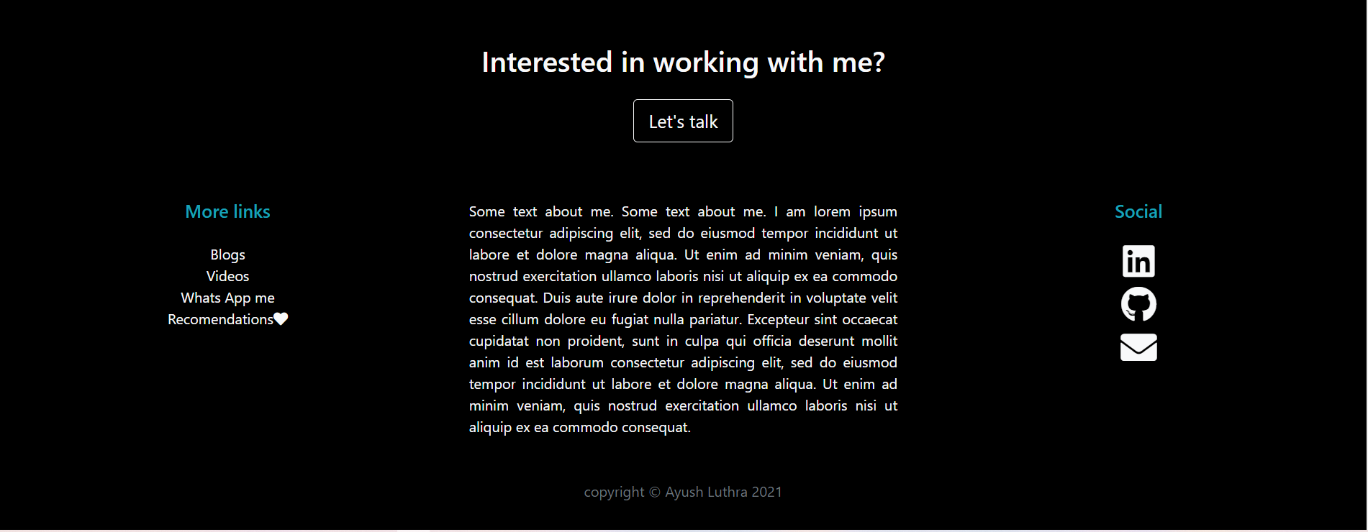

Figure 8 Footer

# REFERECES

1. Blogs of Bhartiya Soft Tech <https://bhartiyasofttech.wixsite.com/website>.
2. YouTube Channel of Bhartiya Soft Tech <https://www.youtube.com/channel/UCrSjZrENoMIvpB5ZjE8n_Ug>